Tip Sheet:
Refusing Signatures and Rerouting to correct person for esigning

If a signature was routed to you by mistake, you can refuse to sign and send to correct person.
When logging into HCS, your patient worklist pops up.
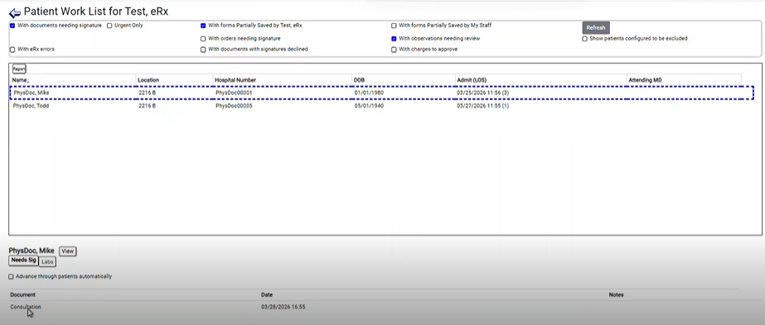
- Select the patient from your work list.
- Select the document you want to refuse due to sent by mistake and needs to be routed to correct person.
- Click “Refuse to Sign”.

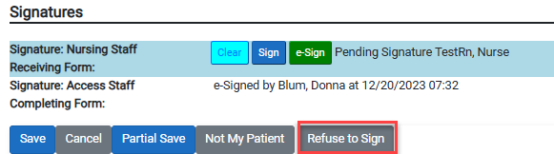
- A popup message will come up, click “Okay”.

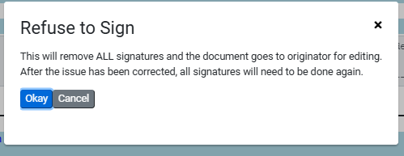
- A Notes box will popup, you will enter why you are refusing to sign and click “Okay”.
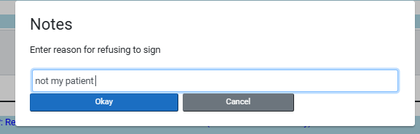
- Your patient work list will now have your comment that you refused and why you refused

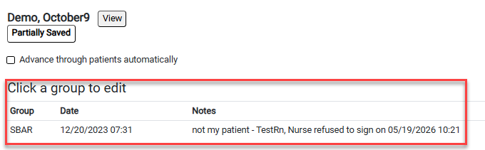
- From your patient work list, double click on the document you just refused, the form will open and you will then reroute to the correct person to sign.
  - Clear where your signature is pending
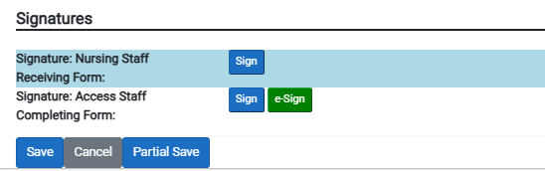

  - Route to correct person, click “Use Signature”.

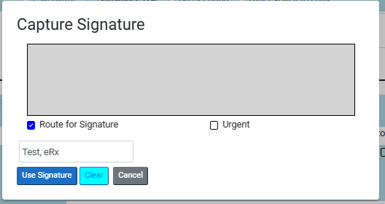

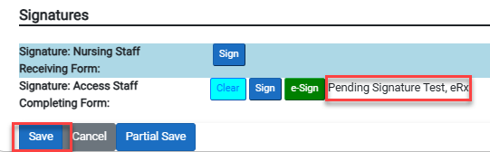
  - Click save

